Lab 6-1 Showing Results as Gauges
Goals | To use the Gauge view to show results as gauges in Siebel Answers.
Scenario | You create a request and display results in a Gauge view using the Dial Gauge type. You set general background properties for the Gauge view, modify gauge ranges, modify gauge titles and footers, set advanced dial gauge properties, duplicate a Gauge view and use a different gauge type to display results, and set gauge interaction to navigate to a saved request.
Time | 15 – 20 minutes
Environment | 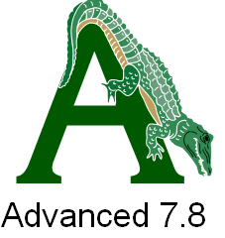
Instructions:
- If necessary, log in to Siebel Analytics as Administrator/Administrator and select the SupplierSales subject area.
- Create the following request and associated filters:
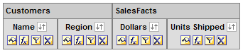
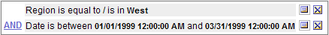
Please note: Delete the Date column from the request after creating the filter.
- Click Results.
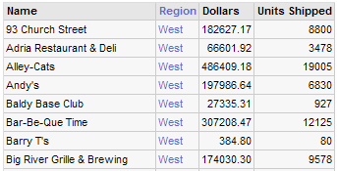
- Add a Gauge view to the Compound Layout view.
  - Click Add View and select Gauge from the Views list.
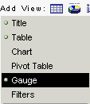
  - In the Gauge view, in the Gauge drop-down list, select Dial.
  - In the Size drop-down list, select Small.
  - In the Measure drop-down list, select Dollars.
  - In the Marker Type drop-down list, select Line.
  - Click the Color button to change the color for the indicator needle.
  - In the Color Selector dialog box, type #000000 to select black as the color of the indicator needle, and click OK.
- Add another marker to the gauges.
  - Click the Add Marker button.
  - In the Measure drop-down list, select Units Shipped.
  - Set Market Type to Line.
  - Change the units shipped marker color to #00FF00.
- Set general background properties for the Gauge view.
  - Click the Gauge Canvas Properties button at the top of the Gauge view page.
  - In the Title section, select Override default.
  - In the Title field, type Q199 Revenue – Units Shipped.
  - If desired, click the Edit Format button next to the Title field to change the format of the title.
  - Verify that legend location is set to Default. The default location of the legend is beneath the title.
  - If desired, click the Edit Format button next to the Legend Location field to change the format of the legend.
  - If desired, use the Borders and Colors section to change the background color for the area in which the gauges appear, the color of the title text, and the color of the border around the gauge area.
  - Change the number of gauges per row to 4. The default is 3.
  - Change the space between gauges to 50. The space between gauges is measured in pixels.
  - Check your work. Your Gauge Canvas properties should look similar to the following:
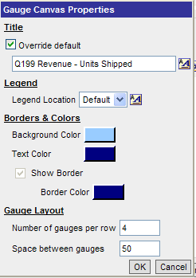
  - Click OK and check your results. There is a gauge for each customer. The black line shows dollars. The green line shows units shipped. The gauge colors show the gauge ranges. Please notice that the screenshot shows only partial results.
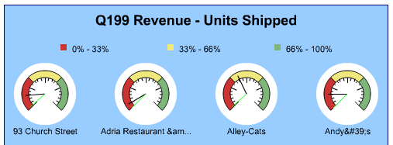
- Modify the gauge ranges.
  - Click the Gauge Ranges button at the top of the Gauge view.
  - By default, the gauge ranges for the dial gauge are set to show percentage of total. Currently, the dial gauge displays three percentage ranges. Click Add to add a fourth range.
  - Click the Color button for the new range.
  - In the color field, type #99CCCC and click OK.
  - Check your results. The dial gauges now display four percentage ranges and the legend captions have changed to reflect the new ranges.
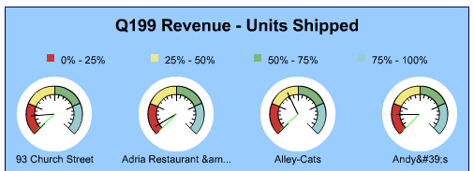
  - Which customer’s revenue for Q199 fell within the 50% – 75% range?
  - Which customer’s revenue for Q199 fell within the 75% – 100% range?
- Modify gauge titles and footers.
  - Click the Gauge Titles button at the top of the Gauge view.
  - In the Title field, type Rev-UnitsShipped.
  - In the Sub Title field, type Q199.
  - In the Footer field, the default is @1. This automatically includes the results from column 1 (Name in this example).
  - In the Secondary Footer field, type @2 Region. This will automatically include the results from column 2 (Region in this example) and append the results with the word “Region”.
  - If desired, click the Edit Format button for any of the fields to change formatting.
  - Check your work.
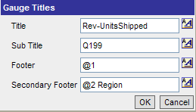
  - Click OK and check your results. Your Gauge view should look similar to the following:
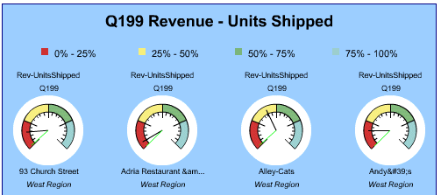
- Set advanced dial gauge properties.
  - Click the Advanced properties button for the dial gauge. The Dial Specific Properties dialog box opens.
  - In the Show scale labels drop-down list, select Actual Value.
  - Under Dial Properties, set Dial Arc Length to 360 and Dial Thickness to 5.
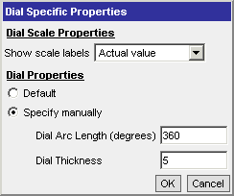
  - Click OK and observe the results. Gauges now appear as a complete circle, dial thickness is reduced, and dollar values appear as scale labels instead of percentages.
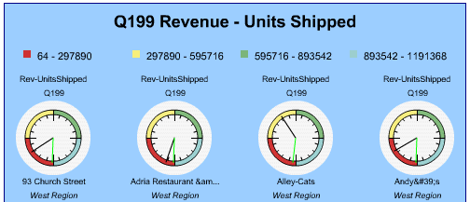
  - Click the Advanced properties button for the dial gauge again and reset all properties to Default.
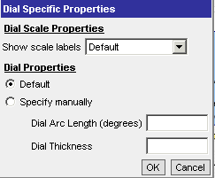
  - Click OK to close the Dial Specific Properties dialog box.
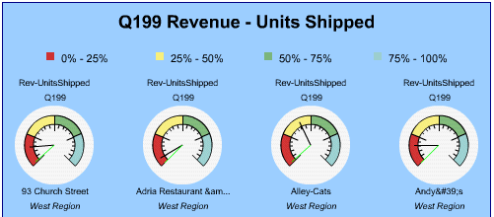
- Set additional gauge properties.
  - Click the Additional Gauge Properties button at the top of the Gauge view. The Additional Gauge Properties dialog box opens.
  - Click the Appearance tab.
  - In the Show data labels drop-down list, select On rollover, which is the same as Default. When selected, data labels appear when a user passes the mouse over the gauge.
  - If desired, modify the background, text, and border appearance of the gauges.
  - If desired, experiment with the size settings. The size is set by default when the gauge size is initially selected. In this case, the gauge size is set to small.
  - Your appearance settings should look similar to the following:
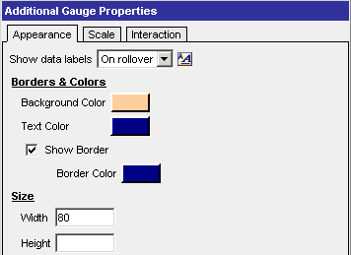
  - Click the Interaction tab.
  - Verify that Default is selected. This allows users to drill down on the gauge to retrieve detail results.
  - If desired, click the Scale tab and experiment with gauge limit and tick mark settings.
  - Click OK to close the Additional Gauge Properties dialog box.
  - Roll over the gauges to verify that data labels appear.
  - Verify that other appearance settings are displayed as expected. Your results should look similar to the following:
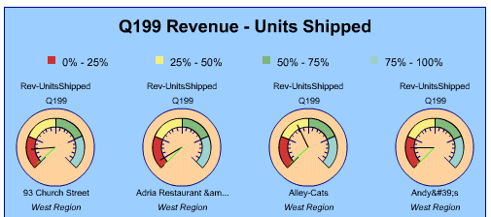
- Create a duplicate Gauge view and use a different gauge type to display results.
  - Click the Duplicate View button at the top of the workspace to duplicate the current Gauge view.
  - Notice that Gauge:2 now appears in the View drop-down list.
  - In the Gauge drop-down list, select Bar.
  - In the Type drop-down list, select Filled.
  - In the Measure drop-down list, select Dollars.
  - Click the Gauge Canvas Properties button and change the title to Q199 Revenue.
  - Click the Gauge Titles button and change the title to Revenue.
  - Modify gauge ranges and gauge properties as desired.
  - Click the Additional Gauge Properties button at the top of the Gauge view. The Additional Gauge Properties dialog box opens.
  - Click the Interaction tab.
  - Select Navigate.
  - Click the Browse button. The Choose Request/Dashboard dialog box opens.
  - Select one of your saved requests. This allows you to click a gauge to navigate to another request or dashboard.
  - Click OK to close the Choose Request/Dashboard dialog box.
  - Check your work. Your results should look similar to the following:
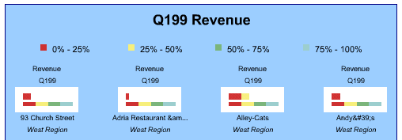
- Modify the Compound Layout view layout.
  - Save the request as My Gauge View.
  - Select Compound Layout from the View drop-down list.
  - Verify that the Compound Layout view contains three views: a Title view that says My Gauge View, a Table view with results from the original request, and the Gauge view as it appeared before you duplicated the view.
  - Select Add View > Gauge2 to add the duplicated Gauge view to the Compound Layout view.
  - Move the Table view to display below the Gauge2 view.
  - Verify that the Compound Layout view now has four views displayed: Title, Gauge, Gauge2, and Table:
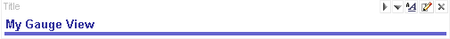
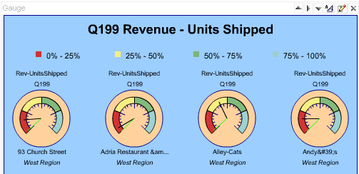
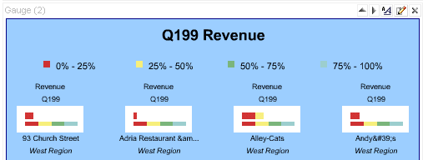
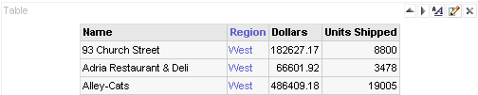
  - Save the request again as My Gauge View.
  - Click Yes when asked to replace existing item with the same name.
- Verify your work.
  - Click the Answers link.
  - Verify that My Gauge View appears under My Folder in the selection pane.
  - Click My Gauge View.
  - Click any dial gauge and verify that results drill down to detail for the selected gauge. Your results should look similar to the following:
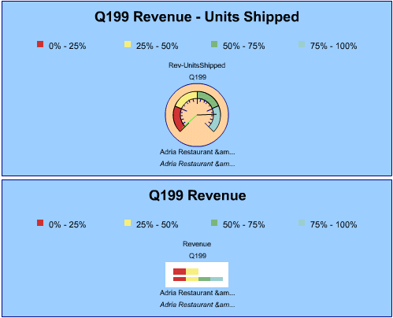
  - Click the bar gauge and verify navigation to the saved request you specified.
- Leave Siebel Answers open for the next lab.

Solutions 6-1
Answers
7.f. Which customer’s revenue for Q199 fell within the 50% – 75% range?
Palestine Club
7.g. Which customer’s revenue for Q199 fell within the 75% – 100% range?
Compound

